# Working and installing and preparing account in GitHub.

* Preparing Account in GitHub
* Steps:

1. Open any internet browser in your Pc or Computer.
2. Search [www.Github.com](http://www.Github.com).
3. Click on the first link and you will see others account and then upper right corner click on sing in or sign up.
4. Click on Create Account.
5. Enter Your Email id and a unique Password.
6. Give a unique Name for you Profile ex: CodeZontes.
7. Here You have created your account in GitHub.

* Installing GitHub Desktop for your PC and Computer Device.
* Steps:

1. Open any Internet Browser in your Pc or Computer.
2. Search Download GitHub Desktop for Computer.



1. Click on Download GitHub Desktop

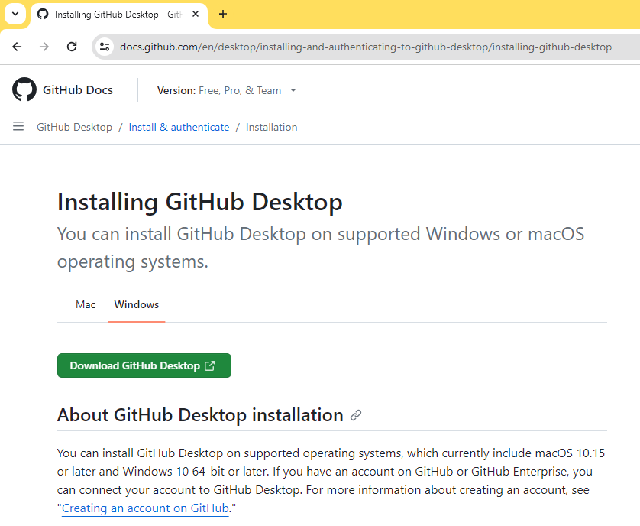

1. Then Click Download For Windows (64 bit )

